

**HOME LIGHTING RULES**

**ATTENTION SUMMERWOOD HOMEOWNERS**

These types of home lights are **only permitted** in Summerwood during the holiday season from **Thanksgiving through early January**:

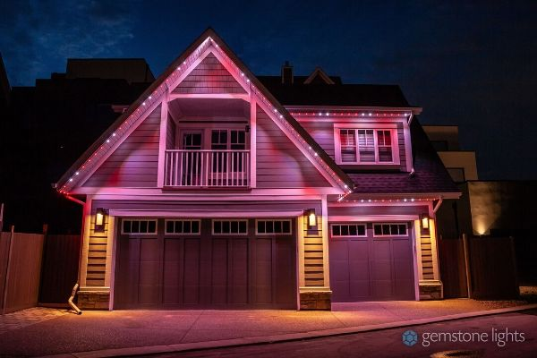

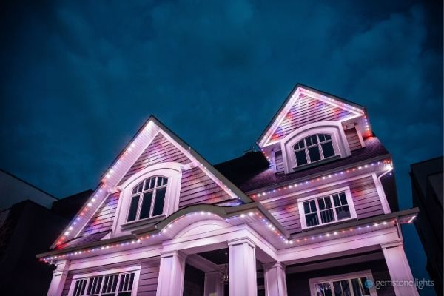

* * * * * * * * * *

Please **READ** the attached Summerwood HOA Home Lighting Rules and **HELP** us preserve the mountain-like atmosphere with our natural surroundings.

Also, a copy of our Protective Covenants, Conditions and Restrictions (CC&Rs) is available on our website: [www.summerwoodestates.com](http://www.summerwoodestates.com). The CC&Rs contain answers to many questions that arise regarding home improvements, landscaping, lighting and more. As a reminder, pre-approval from the Architectural Committee is required before you make any changes, modifications, improvements or alterations to your home, yard or property.

Thank you for your cooperation and for making our neighborhood the best place to live in Bountiful!

David Angerbauer Dain Black Jaime Kendall

*President Treasurer Secretary*

Bill Richter Grant Bailey

*Chair, Architectural Committee Member, Architectural Committee*